At Literacy Partners Gala, Bestselling Authors Share Personal Stories
By Nancy Lazarus on Apr. 15, 2015 - 3:20 PM
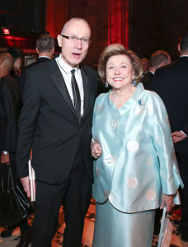Liz Smith, the “patron saint of literacy,” was unable to host Tuesday night’s gala at Cipriani in New York for Literacy Partners, the organization she helped found in 1974. Though Smith felt under the weather, her fellow board of directors, as well as honorees Robert Thomson and Barbara Taylor Bradford (pictured, at right), along with writers Tom Brokawand Ali Wentworth (pictured, below), aptly filled in for her. Resilience emerged as the recurring theme of the evening, much like Smith herself.
Literacy Partners student Matthew Brown represented one of the evening’s highlights. The 75-year-old detailed his lifelong struggle to read, which he overcame with the organization’s help. He then sang his own resounding rendition of the Sinatra hit, “My Way,” to a standing ovation.
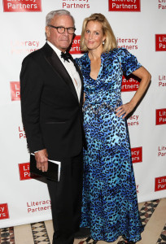
Taylor Bradford received the Lizzie award for her devotion to literacy in the U.S. and the U.K. She spoke about her prolific writing career, starting at a regional newspaper in England. “I had a little bit of toughness, even at age 16,” she said. By age 20 she headed to Fleet Street, and never forgot the lessons of needing to answer the “who, what, where, when and why’s.”
Thomson was honored for his philanthropy and commitment to the literacy cause, and joked that he also wants “numeracy partners for fiscally challenged executives.” On a more serious note, he spoke about the challenges that those who can’t read face every day, when words become enemies, leading to social isolation. “No one among us can always find the right words. Cracking the code of language is crucial,” he added.
Thomson also piqued the audience’s curiosity by bringing a book to the stage that he said was Harper Lee’s much anticipated ‘prequel sequel’, though it turned out to be her bestseller, To Kill A Mockingbird. “I’ve read the manuscript, and I think it will resonate,” he told the crowd.
Brokaw and Wentworth read passages from their upcoming books, both due out later this spring. Wentworth’s tale, Happily Ali After, describes humorous scenes from her life based on well-known sayings. She disagrees with the famous Love Story quote about never having to say you’re sorry. “Love has always meant saying I’m sorry repeatedly,” she said. An example: when her family planned a trip to Spain but upon arrival at JFK airport discovered that their girls’ passports had expired.
Brokaw’s forthcoming memoir, A Lucky Life Interrupted, recounts his deeply personal journey battling multiple myeloma, a treatable but incurable form of cancer. He spoke about first experiencing symptoms and then being diagnosed at the Mayo Clinic. “I went from the delusion of being ever young. It was a way of life that I couldn’t believe was slipping away from me,” he said. He ended on a more upbeat note now that his cancer is in remission, citing “renewable cycles of life.” The book concludes with these words: “Life–what’s left–bring it on.”
(Photos courtesy of Billy Farrell Agency)

